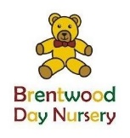

Registration fee and bank details
In order to register your child at the nursery, non funded children must pay a non-returnable registration fee of £40. You will receive a complimentary child’s nursery polo shirt or sweatshirt.

All funded children are asked to pay a voluntary admin contribution of £40, this goes towards a nursery polo shirt or sweatshirt, library bags, placemat, art folder and the online journal subscription for EY log.

Additional uniform can be purchased at an additional charge.
This is added to the first invoice, alternatively you can process the payment via BACS to:

Brentwood Day Nursery (business account)
Account number: 00348567 Sort code: 30-91-17
or by cheque to be made payable to Brentwood Day Nursery

